[Company's Name]

[Company Name]
[Address]
[City, State, Zip]
[Website: https://www.URL]

[Name of Owner or Contact], [Title]
[Phone]
[Email]
Contents
Business Plan Confidentiality Agreement 3
Executive Summary 4
Purpose 4
Introduction 4
Problem/Need 4
Solution 4
The Market Size 5
Competitive Advantages 5
Ownership & Management 6
Funding 6
Company Structure 7
Overview 7
Legal Structure 7
Founded 7
Ownership 7
Location 7
Mission 7
Vision 7
Hours of operation 7
Company Summary 8
Company Description 8
Products & Services 9
Menu 9
Images 11
Suppliers Description 12
Supply Chain 12
Key Buying Industries 12
Key Selling Industries 12
Revenue: Pricing and Profitability 12
Goals 13
Milestones 13
Keys to Success 14
Competition & Competitive Advantages 14
Competition 14
Competitive Advantages 14
Management Summary 16
Management / Key Roles 16
[Name, Title] 16
[Name, Title] 16
[Name, Title] 16
Management Summary 16
Personnel Plan 17
The Market Size & Trends 18
Local Demographics 21
Target Market 24
Marketing Strategy 25
Marketing 25
Web Plan 26
Sales Strategy 26
Positioning 26
Pricing 26
SWOT Analysis (optional) 27
Strengths 27
Weaknesses 27
Opportunities 27
Threats 27
Funding 28
Funding 28
Use of Funds/Costs 28
Exit 28
Conclusion 29
Appendix 30
Financial Plan 30
Other 30

(Note: right click on the Table of Contents to auto update contents of the table)

Business Plan Confidentiality Agreement

The undersigned reader of [Company's Name] Business Plan hereby acknowledges that the information provided is completely confidential and therefore the reader agrees not to disclose anything found in the business plan without the express written consent of [Business Owner's Name(s)].
It is also acknowledged by the reader that the information to be furnished in this business plan is in all aspects confidential in nature, other than information that is in the public domain through other means and that any disclosure or use of the same by the reader may cause serious harm and or damage to [Company Name].
Upon request this business plan document will be immediately returned to [Business Owner's Name(s)].

___________________
Signature

___________________
Name (typed or printed)

___________________
Date

This business plan does not imply an offering of securities.

Executive Summary
(Note: The executive summary is a mini version of the plan and can be somewhat repetitive. You can do this section last.)

Purpose
The purpose of this business plan is to raise $____ for the ____ (i.e. development, expansion) of a [type of restaurant] restaurant while showcasing the expected operations over the next five years. The Company was founded by [Business Owner's Name(s)].

Introduction
[Company Name] (Also referred to as “The Company”) is a start-up [type of restaurant; i.e. French, Mexican, etc.] restaurant. The menu will be inspired from ____ (i.e. different countries' specialties, or family recipes, or a twist on Asian) to appeal to a diverse range of customers. The establishment is located in [City, State]. The outlook for the future of [City] is promising. (If a start-up add: The restaurant will launch on ____ 202_.) The restaurant will be open _____ days a week.
The restaurant offers ______________________________________________.
(Example: a variety of food, beverages, desserts, catering, and take-out options. This is a good place to mention anything special such as, the restaurant offers unique pastries with a Peruvian flare, etc.)

Problem/Need
(Example 1: There are currently no Asian restaurants in the city, or there is a demand for Asian infusion in the area, or there is a business complex nearby that has a large processional population with few lunch establishments in the area.)
(Example 2: The area is in need of a warm and friendly place with excellent food. A place where you always know you will get the best of everything.)

Solution
The restaurant will solve this problem/need by ______________________.
(Example 1: The restaurant will solve this problem by opening up an Asian restaurant that will focus on Asian infusion and offer lunch service for local professionals that work in the nearby business complexes)
(Example 2: ABC Restaurant will feature a cozy dining room and comfortable furnishings and decor with soothing warm tones. The lounge has comfy couches and love seats with a bar. It will be the perfect place to stop in for a bite to eat, for a drink or for a small business meeting.)

The Market Size
(In this section search online for a few statistics that show the industry size.)
(Example 1: taken from https://restaurant.org:
Restaurant Industry Facts at a Glance (always add a source or footnote)
- $899 billion: Restaurant industry's projected sales in 2020
- 1 million+: Restaurant locations in the United States
- 15.6 million: Restaurant industry employees
- 1.6 million: New restaurant jobs created by 2030
- 9 in 10 restaurant managers started in entry-level positions
- 8 in 10 restaurant owners started their industry careers in entry-level positions
- 9 in 10 restaurants have fewer than 50 employees
- 7 in 10 restaurants are single-unit operations
- Restaurants employ more minority managers than any other industry
- 63% of consumers would rather spend on an experience than purchase an item
- The number of middle-class jobs ($45K-$75K) in the restaurant industry grew 84% between 2010 and 2018, more than 3 times faster than in the overall economy.)

Competitive Advantages
[Company Name] will have several competitive advantages including:
(Example: pick 3-5 things such as the examples below)
- Location
- Type of Food
- Healthy Choices
- Quality Ingredients
- Friendly staff
- Convenience
- Affordable

Ownership & Management
The management team is comprised of individuals whose backgrounds consist of ___ years experience in the food, restaurant, and hospitality industries.
(Biography, experience, or resume will go below in the plan; here just mention the owner(s)/manager(s) name and title, with a few sentences about experience)
[Name, Title] - [Experience]
[Name, Title] - [Experience]
[Name, Title] - [Experience]
(Example: John Smith, CEO: John has 15 year of experience as a restaurant manager and 10 years as an Owner Operator. He has owned and operated two prior businesses that he sold for a profit in 2010. He looks forward to this next venture.)

Funding
[$Amount] of funding is needed over the next year for [Insert uses here]. (Example: renovations, furniture, kitchen equipment, liquor license, food, & restaurant supplies, legal fees, working capital, marketing, and personnel.)
OR
[No funding is needed at this time. The owners have provided the company with sufficient capital.]

Continue reading the business plan below.

Company Structure

Overview

Legal Structure
The legal structure of the [Company Name] is a _____________.
(Examples below)
- Limited Liability Company (LLC)
- Corporation
- Partnership
- To be determined / Pending

Founded
[Month, Year]

Ownership
The Company is owned by:
[Owner's Name: xx%].
[Owner's Name: xx%].

Location
[Address]

Mission
[Insert Mission Statement here]
(Example 1: To be the top rated Asian infusion establishment in the area.)
(Example 2: [Company Name] is a great place to eat, combining an intriguing atmosphere with excellent, interesting food. The mission is not only to have great tasting food, but have efficient and friendly service because customer satisfaction is paramount. We want to be the restaurant choice for all families)

Vision
[Insert Vision Statement here (optional)]
(Example: To make a difference in our community by bring diverse food into the area and giving back to the community in which we serve.)

Hours of operation
[Insert days and Hours of Operation. i.e. Tuesday - Sunday 11:00 am - 11: 00 pm EST, closed Monday.]

Company Summary

Company Description
[Company Name] offers ______________________________________________.
(Example: a variety of food, beverages, desserts, catering, and take-out options. This is a good place to mention anything special such as, the restaurant offers unique pastries with a Peruvian flare, etc.)
(Another example: ABC Restaurant sells coffee, other beverages and snacks.)
[Company Name] intends to cater to ___________ (i.e. a wide group of people, college students, professionals, etc.) [Company Name] wants everyone to feel welcome and relaxed in a ______ (i.e. cozy, modern, family oriented, etc.) atmosphere with a _____________ (i.e. wide and varied, gourmet, unique, classic, etc.) menu. The Company goal is to have _________ (i.e. "something for everyone", "unique flavors", "fresh farm-to-table options", etc.) on the menu. (See example menu below)
The ________ setting will be a _______ atmosphere for the ______ crowds. (I.e. The patio and garden setting will be a fun and casual atmosphere for the summer crowd.) The service will be ____________. (I.e. relaxed, very friendly and speedy). The Establishment will hire the best people available, training, motivating, and encourage them, and thereby retaining the friendliest most efficient staff possible. The management team is comprised of individuals whose backgrounds consist of ___ years experience in food, restaurant, catering, management, and customer service. Catering will be a major part of the business. Now customers can leave it to [Company Name] to get the finest, most memorable party or food ever. The establishment will be offering high-quality service and excellent food.

Products & Services
The restaurant will provide the following products and services:
- [insert]
- [insert]
- [insert]
Explain what products services you will be providing: i.e.
- Type of food
- Beverages
- Snacks
- Desserts
- Catering
- Take-Out
- Theme Nights

Menu
The menu will be inspired from ___________________. (I.e. different countries' specialties and appeal to a diverse clientele) with specialties like _______________ (i.e. herring and meatballs). The establishment will also have _______ (i.e. daily specials). Adding value will be an interesting _____ (i.e. business lunch menu, or dessert menu) with specialties every day. The menu will change ______ (i.e. every 3-4 months) but keep the favorites. Prices will be ________ (i.e. competitive with other restaurants in the area). However, it is the strategy of [Company Name] to give a perception of higher value than its competitors, through its food, service and entertainment.
Here is an example of the restaurant's menu:
[Here is where you put your sample menu, written or visual]
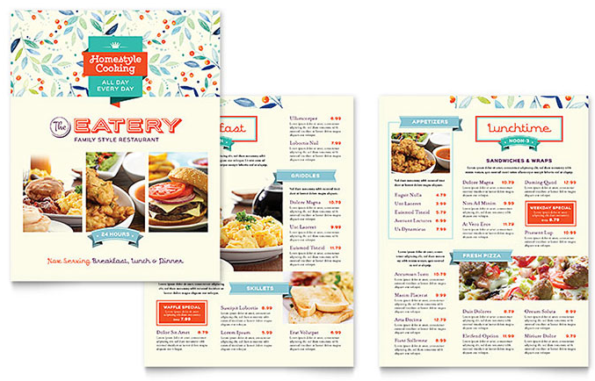
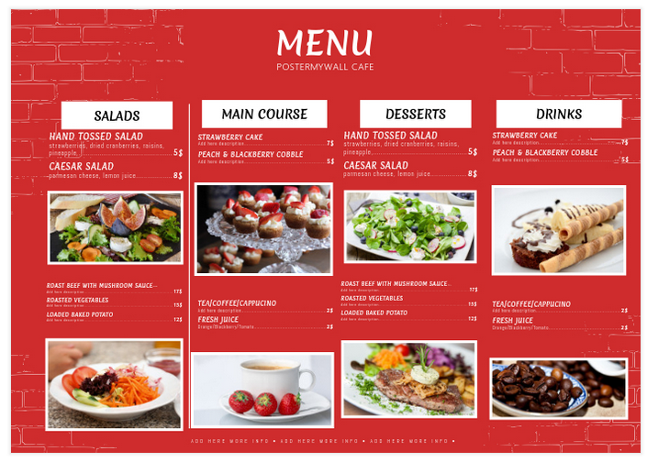

Images
[Inset any additional images here of the establishment or food]

Suppliers Description (Optional)

Restaurant Supply Chain(optional)

Key Buying Industries
Consumers in the US
Households are the key drivers of demand for this industry’s products.

Key Selling Industries
Frozen Food Wholesaling in the US
This industry supplies frozen food products.
Dairy Wholesaling in the US
This industry supplies dairy products.
Egg & Poultry Wholesaling in the US
This industry supplies poultry products.
Fish & Seafood Wholesaling in the US
This industry supplies fish and seafood products.
Beef & Pork Wholesaling in the US
This industry supplies meat and meat products.
Fruit & Vegetable Wholesaling in the US
This industry supplies fresh fruit and vegetables.
Beer Wholesaling in the US
This industry supplies beer and ales.
Wine & Spirits Wholesaling in the US
This industry supplies wine & spirits.

Revenue: Pricing and Profitability
[Explain how you will make money with the business.]
The restaurant will make money from ____________________________________.
(Example: The restaurant will make money from the sale of food, beverages, alcohol, desserts, catering, and take-out. Prices will be competitive with other upscale restaurants in the area.)
Pricing
- Meal Price range from $___ – $____
- Average lunch price: _____
- Average dinner price: ______
The dining room will have a seating capacity of ____ seats as well as additional outside seating.
The goal of the establishment is to have [number of customers] with an average ticket of [Estimated average per ticket] over the next 12 months, which will result in estimated revue of [Estimated revenue the next 12 months].
(I.e. The goal of the establishment is to have 125 customers per day with an average ticket of $40.00 over the next 12 months, which will result in estimated revenue of $1,560,000.)

Goals
[Company Name] has established goals in order to fulfill its objective of operating and growing this business establishment:
- Grow the business in the local market by offering quality [type of food] and other products.
- Build a strong leadership team to lead [Company Name] in to the future.
- Keeping food cost under ___ % of revenue. (I.e. 35%)
- Keeping employee labor cost low without sacrificing quality of service by efficient scheduling.
- Averaging sales between ___ - ______ per year. (i.e. $1,000,000-1,500,000 per year)
- Promote and expand ___ (i.e. catering, take-out, events, etc.)
- Expand our marketing and advertising in the local area.
- Increase sales and revenue each year by ___%. (I.e. 10%)

Milestones
[Company Name] expects to achieve the following milestones:
Date | Milestone
[Date 1] | Finalize lease agreement
[Date 2] | Design and build out [Company Name]
[Date 3] | Hire and train initial staff
[Date 4] | Launch [Company Name]
[Date 6] | Reach Sales goal of $ ______

Keys to Success
- The creation of a unique and innovative _____ (i.e. fine dining) atmosphere will differentiate us from the competition. The restaurant will stand out from the other restaurants in the area because of the _______ (i.e. design and decor).
- Food product quality. Not only great food but great service and atmosphere.
- The menu will appeal to a wide and varied customer base.
- Controlling costs at all times.

Competition & Competitive Advantages

Competition
Competition in the local area is _____ (I.e. somewhat sparse) and does not provide _______ (I.e. nearly the level of product quality and customer service customers are looking for a high quality product in a relaxing atmosphere). They desire a unique, high-quality experience.
[Company Name] faces competition from the following companies:
- (Competition name) – Brief description.

- (Competition name) – Brief description.

- (Competition name) – Brief description.

(Example: Chinese Star - website - location - Offers Chinese food in the local area; however, they do not offer Asian infusion or catering options.

Competitive Advantages
The [Company Name] competitive advantage is __________ (I.e. the menu, the chef, the environment, the management, the service, and our friendly place!)
OR
[Company Name] will have several competitive advantages including:
(Example: pick 3-5 things such as the examples below)
- Location
- Type of Food
- Quality Ingredients
- Friendly staff
- More variety than any of the closest competitors
- Appropriate and ample hours of operation
- Competitive pricing

Management Summary
The restaurant will be owned by [Insert Owners name(s) here].

Management / Key Roles
[Name, Title] - [Experience, biography, or resume]
Role: [Name] will be responsible for ______. (I.e. operations, marketing, etc.)
[Name] is a [title] who has ___________ -years of experience of working in _______.
[Name] is good at _____________, _____________, and_____________. (I.e. communicating, leading, training, etc.)
Other:
[Name] graduated from the ______ University with a Bachelor's degree in __________.
[Name] has experience as ______.
[Name] delivers __________.
[Name] is in charge of ___________.
[Name] led the _______.
[Name, Title] - [Experience, biography, or resume]
Role: [Name] will be responsible for ______. (I.e. operations, marketing, etc.)
[Name] is a [title] who has ___________ -years of experience of working in _______.
[Name] is good at _____________, _____________, and_____________. (I.e. communicating, leading, training, etc.)
[Name, Title] - [Experience, biography, or resume]
Role: [Name] will be responsible for ______. (I.e. operations, marketing, etc.)
[Name] is a [title] who has ___________ -years of experience of working in _______.
[Name] is good at _____________, _____________, and_____________. (I.e. communicating, leading, training, etc.)

Management Summary
[Company Name] recognizes that in any growing Company management personnel often have to fill more than one role. As a result, a gap or gaps may exist until the Company is developed enough to have a specific person for every task required. [Company Name] currently has everything covered and feels confident that each task is being handled competently by management.
The management team is well compensated. [Company Name] has a team that has considerable experience together and shares knowledge in many different fields of business and in life.

Personnel Plan
Management has adopted an effective interview process designed to staff the restaurant with highly qualified people for each position. Each applicant will be rated and evaluated according to a pre-defined set of standards designed for each position. Background checks will be utilized for designated positions. Recruiting efforts will always center on referrals.
[Company Name] knows the personnel plan is in good proportion to the size of the restaurant and projected revenues. The staff will include both full-time employees and part-time employees, who will work various shifts based on peak hours and need.
Functional Roles
In order to execute on [Company Name]’s business model, the Company needs to perform many functions including the following:
(Pick any that apply)
- General Manager
- Front Manager
- Waitperson
- Wait/Barperson
- Bartender
- Busboy
- Head Chef
- Sous Chef
- Cook
- Prep Cook
- Dishwasher
- Cleaning
Great service is very important to management. The management and servers will handle every detail to make customer's dining experience memorable! All this and the great atmosphere will make customers want to come back again.

The Market Size & Trends
(Insert as many or as few examples, reports, stats, or tends as you want, just make sure to add the sources in the text or footnote.)
Example: taken from the Nation’s Restaurant Association at https://www.nrn.com:
U.S. restaurant industry sales will reach a record high of $863 billion this year, up 3.6% over last year, according to a report released today by the National Restaurant Association.
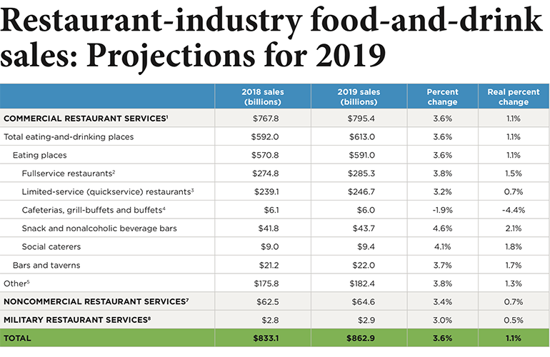
More than half, or 51%, of consumer spending on food in the United States is allocated to restaurants, Riehle said, compared to 1955 when that was 25%.
About 90% of consumers like to spend money in restaurants, Riehle said, and the environment is becoming easier for those expenditures with more sophisticated with digital menu boards and kiosks.
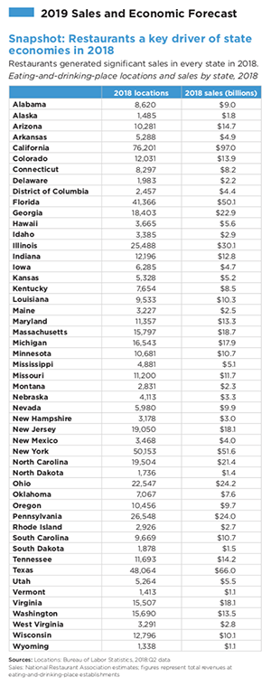
Regional differences
The Mountain and Pacific regions are projected to experience the highest population growth rates, one of the main factors in restaurant sales increases, over the next 10 years, Riehle said. However, U.S. Census Bureau projections for states in the Northeast and Great Lakes regions forecast less than 1% population growth.
“That makes it an entirely different operating environment than it is in a Mountain or Pacific location,” he said.
This year, however, all 50 states have positive sales growth projected for this year.
Substantial pent-up demand remains for restaurant services, the State of the Industry survey found.
“Over the next decade,” he said“, technology will link restaurant spending with other consumer-spending categories.”
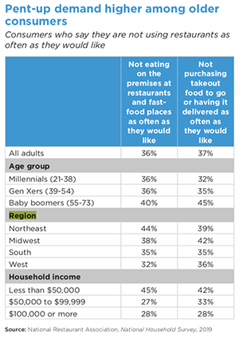
Note: Industry Reports can sometimes be found online or purchased; and summarized here.

Local Demographics
(You can use the census, census quick-facts, or online search to discover demographics in the city or county in which your establishment resides)
Example 1:
Fact | Salt Lake City, Utah
Population estimates, July 1, 2019, (V2019) | NA
Population estimates, July 1, 2018, (V2018) | 200,591
Population estimates base, April 1, 2010, (V2019) | NA
Population estimates base, April 1, 2010, (V2018) | 186,443
Population, percent change - April 1, 2010 (estimates base) to July 1, 2019, (V2019) | NA
Population, percent change - April 1, 2010 (estimates base) to July 1, 2018, (V2018) | 7.60%
Population, Census, April 1, 2010 | 186,440
Persons under 5 years, percent | 6.40%
Persons under 18 years, percent | 20.60%
Persons 65 years and over, percent | 10.80%
Female persons, percent | 48.60%
White alone, percent | 73.10%
Black or African American alone, percent | 2.30%
American Indian and Alaska Native alone, percent | 1.40%
Asian alone, percent | 5.40%
Native Hawaiian and Other Pacific Islander alone, percent | 1.50%
Two or More Races, percent | 3.40%
Hispanic or Latino, percent | 21.60%
White alone, not Hispanic or Latino, percent | 65.40%
Veterans, 2014-2018 | 7,012
Foreign born persons, percent, 2014-2018 | 16.70%
Housing units, July 1, 2018, (V2018) | X
Owner-occupied housing unit rate, 2014-2018 | 48.40%
Median value of owner-occupied housing units, 2014-2018 | $289,200
Median selected monthly owner costs -with a mortgage, 2014-2018 | $1,534
Median selected monthly owner costs -without a mortgage, 2014-2018 | $482
Median gross rent, 2014-2018 | $938
Building permits, 2018 | X
Households, 2014-2018 | 78,229
Persons per household, 2014-2018 | 2.43
Living in same house 1 year ago, percent of persons age 1 year+, 2014-2018 | 78.50%
Language other than English spoken at home, percent of persons age 5 years+, 2014-2018 | 26.40%
Households with a computer, percent, 2014-2018 | 92.80%
Households with a broadband Internet subscription, percent, 2014-2018 | 81.80%
High school graduate or higher, percent of persons age 25 years+, 2014-2018 | 88.50%
Bachelor's degree or higher, percent of persons age 25 years+, 2014-2018 | 45.70%
With a disability, under age 65 years, percent, 2014-2018 | 7.40%
Persons without health insurance, under age 65 years, percent | 15.10%
In civilian labor force, total, percent of population age 16 years+, 2014-2018 | 71.20%
In civilian labor force, female, percent of population age 16 years+, 2014-2018 | 64.80%
Total accommodation and food services sales, 2012 ($1,000) | 961,646
Total health care and social assistance receipts/revenue, 2012 ($1,000) | 3,140,405
Total manufacturers shipments, 2012 ($1,000) | 11,969,157
Total merchant wholesaler sales, 2012 ($1,000) | 10,292,791
Total retail sales, 2012 ($1,000) | 4,071,084
Total retail sales per capita, 2012 | $21,504
Mean travel time to work (minutes), workers age 16 years+, 2014-2018 | 19.4
Median household income (in 2018 dollars), 2014-2018 | $56,370
Per capita income in past 12 months (in 2018 dollars), 2014-2018 | $34,711
Persons in poverty, percent | 17.90%
Total employer establishments, 2017 | X
Total employment, 2017 | X
Total annual payroll, 2017 ($1,000) | X
Total employment, percent change, 2016-2017 | X
Total nonemployer establishments, 2017 | X
All firms, 2012 | 24,710
Men-owned firms, 2012 | 13,482
Women-owned firms, 2012 | 6,970
Minority-owned firms, 2012 | 3,327
Nonminority-owned firms, 2012 | 19,325
Veteran-owned firms, 2012 | 1,969
Nonveteran-owned firms, 2012 | 20,510
Population per square mile, 2010 | 1,678.00
Land area in square miles, 2010 | 111.11
FIPS Code | "4967000"
Example 2:
Salt Lake City demographics profile
Statistic | Salt Lake City | Utah | National
Population | 191,446 | 2,948,427 | 318,558,162
Population density (sq mi) | 1,722 | 40 | 91
Median age | 31.8 | 30.3 | 37.7
Male/Female ratio | 1.1:1 | 1.0:1 | 1.0:1
Married (15yrs & older) | 46% | 60% | 55%
Families w/ Kids under 18 | 47% | 51% | 43%
Speak English | 73% | 85% | 79%
Speak Spanish | 16% | 10% | 13%
Salt Lake City, UT has a population of 191,446 and is the 127th largest city in the United States. The population density is 1,722 per sq mi which is 4204% higher than the Utah average and 1800% higher than the national average. The median age in Salt Lake City is 32 which is approximately 5% higher than the Utah average of 30. In Salt Lake City, 46% of the population over 15 years of age are married, 73% speak English, and 16% speak Spanish. 48% of Salt Lake City residents were born in Utah, 34% were born out of state, 1% were born outside of the United States, and 18% were foreign born.
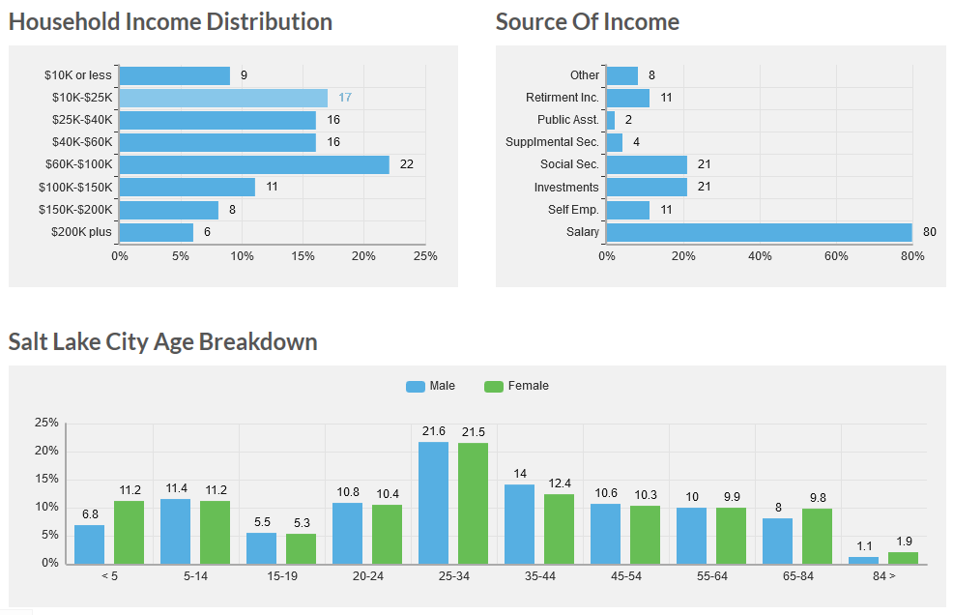

Target Market
[Company Name] focuses on ________. Such as, ______________.
(Example: ABC restaurant focuses on local and tourist restaurant seekers. Such as, people that have a desire for good food and a fascinating atmosphere.)
OR
The target market is:
- [insert]
- [insert]
- [insert]
Example: Who your customers will be and where will you target them?
I.e. women ages 18-40
I.e. college students in the area
I.e. professional offices for lunch business

Marketing Strategy
The strategy is simple, [Company Name] intends to succeed by giving people excellent food in an environment that appeals to a varied group of people. [Company Name] will focus on maintaining quality and establishing a strong identity in the area. The main focus in marketing will be to increase customer awareness in the surrounding area. [Company Name] will direct all of our marketing efforts toward the goal of explaining who [Company Name] is and what [Company Name] does. [Company Name] will keep our standards high and execute the concept so that word-of-mouth will be the main marketing force.
[Company Name] will create an appealing and entertaining environment with quality at a competitive pricing. An exciting [new, established] restaurant, [Company Name] will be talked about. Therefore, the execution of our concept is the most critical element of this plan. All menu items are competitively priced for the area. While the Company is not striving to be the lowest-priced restaurant, [Company Name] is aiming to be the _____ (i.e. value leader).

Marketing
[Company Name] utilizes several marketing methods include the following:
(Pick 3-7 methods you will use, examples below)
- [Insert]
- [Insert]
- [Insert]
- Grand Opening Celebration.
- Advertising
- Local Media
- Emails
- Flyers, Business Cards, Brochures
- Mobile Marketing
- Networking/PR
- Search Engine Optimization
- Social Media
- Website Design
- Word-of-Mouth
- In-store Marketing
- Yellow Pages Advertisements

Web Plan
[Company Name] will have a website.
URL: _______________
[Company Name] understands the importance of a website and online menu.
It will be the virtual business card and portfolio for the company, simple, classy, and well designed. The site will offer the menus, prices, reviews, and happenings at [Company Name]. [Company Name] will also have a social media accounts to get new customers interested in the restaurant food. Customers will also be able to send us an E-mail or book catering orders online.

Sales Strategy
The sales plan is to establish and maintain position with the local customers. The strategy is to build more customers in order to increase revenue and repeat business. The Company will focus on making all customers happy with the food, beverage, and service options.
[Company Name] will have an experienced staff that knows the food and menu inside and out. The Company will train every new employee.

Positioning
[Company Name] takes the position that its primary role in the marketplace is being a provider of top quality, [type of food] restaurant for ______ (i.e. everyday people, professionals, etc.). This is how [Company Name] will distinguish itself in the marketplace. The Company wants the target customers to think about [Company Name] whenever people think about the best place for [type of food]. The Company wants them to choose [Company Name] because people associate it with quality.

Pricing
[Company Name] seeks a balance between quality of offering, price, and the value that may be derived from the competition. The Company believes it offers the best balance of these aspects in the minds of the target customers. Ultimately, the Company wants to ensure that all of the target customers equate [Company Name] with ___ (i.e. great value).

SWOT Analysis (optional)
(Pick 3-5 in each category; examples below)

Strengths
- [insert]
- [insert]
- [insert]
  - Industry trends
  - Growth market
  - High quality ingredients
  - Variety of menu items
  - Unique atmosphere

Weaknesses
- [insert]
- [insert]
- [insert]
  - High operation cost
  - Increased price on ingredients
  - Limited amount of vendors
  - Turn-over in the industry

Opportunities
- [insert]
- [insert]
- [insert]
  - Little competition in the local area
  - Vendors
  - Development of alternative menu items to lower price points
  - Introduce healthier food options
  - Use technology (mobile app, online coupons, etc.)

Threats
- [insert]
- [insert]
- [insert]
  - Trends may change
  - Emergence of local competition or new competition
  - Copy Cats

Funding

Funding
[$Amount] of funding is needed over the next year for [Insert uses here]. (Example: renovations, furniture, kitchen equipment, liquor license, food, & restaurant supplies, legal fees, working capital, marketing, and personnel.) Total costs will be $____, $____ of which will be contributed by the [owner(s)] and the remainder will be secured through ________ (i.e. a proposed bank loan).
OR
[No funding is needed at this time. The owners have provided the company with sufficient capital.]

Use of Funds/Costs
Total costs are estimated to be:
- [Insert]
- [Insert]
- [Insert]
Examples:
- Building $___
- Equipment $ ____
- Insurance
- Inventory
- Legal
- Marketing
- Renovations
- Technology
- Working capital

Exit
[Company Name] is _______. (I.e. not looking to exit at this time, looking to sell in 5-10 years, etc.)

Conclusion
Thank you for reading.
[Company Name] would like to_________. (I.e. introduce “ABC restaurant in Salt Lake City, Utah.)
This business plan contains an overview of all the planning that is required for this business. Location, staff, food, and service quality etc. are some important aspects that the [owner(s)] of the restaurant will focus on. Strategic plans for marketing, human resources, and menus will be prepared as mentioned above.
With the growing demand for high-quality food and great service, [Company Name] will capitalize on its proximity to [Location] to build a core group of repeat customers.
The [owner(s)] believe that this concept will provide ______ (i.e. new) experiences to the local customers.
[Company Name] believes that its prospects for establishing and continuing a successful restaurant in this community are excellent.
The [Owner(s)] seeks a relationship with a [lender/investor] that can help [Company Name] grow the business.
[Company Name] values your time, and hopes that you’ve learned all about the [Company Name] vision, goals, opportunities, and value.

Appendix

Financial Plan

Other

https://restaurant.org/research/restaurant-statistics/restaurant-industry-facts-at-a-glance
Suggested based off restaurant industry codes/related
https://www.nrn.com
https://www.census.gov/quickfacts/fact/table/saltlakecitycityutah/PST045219

